Power BI Workbook 2 _______________________________________________________

Part 2: Data Enhancement (Joins)

* **Inner join:**

*How many orders have been returned?*

*98 orders have been returned*

* **Left outer join:**

*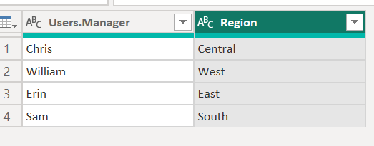Which managers are associated with orders in each region?*

*Are there any managers without associated orders? No*

* **Right outer join/ Inner Join (Preferably)**

*Are there any orders from regions not assigned to a manager in the Users table? No*

Part 3: Data Profiling

* **Column Distribution:**

*Examine the column distribution for Order Priority and Customer Segment in the Orders table.*

*What are the most common values in each column?*

*Most common values are in following order In Order Priority column*

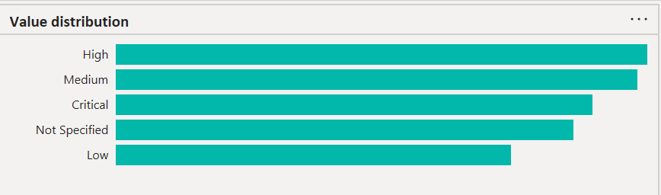

*Most common values are in following order In Customer Segment column*

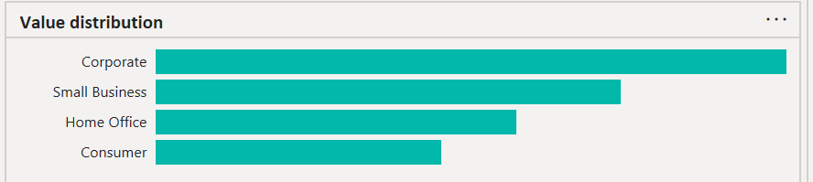

* **Distinct and Unique Values:**

*How many distinct Ship Mode options are there in the Orders table?*

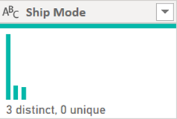

*How many of those are unique (used only once)? None of them is unique*

* **Data Quality:**

*Check the column quality for Product Base Margin in the Orders table.*

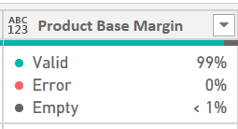

*Are there any errors or missing values?Yes 1% empty values: 6 missing values*